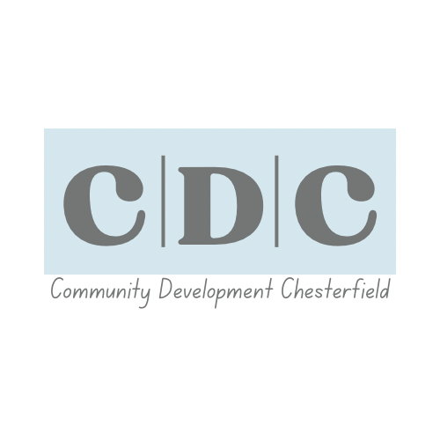
CDC Family Policy
At Community Development Chesterfield, we believe that we are more than a team. We are a family.
The term “CDC Family” represents everyone who contributes to making our charity what it is. This includes staff, volunteers, community partners and participants. We work together, support one another and celebrate the positive difference we make in our community.
Being part of the CDC Family means taking pride in what we do, caring for the spaces we use and treating each other with kindness and respect. We all share one goal: to make our community a better, warmer and more connected place for everyone.

05 November 2025, Reviewed yearly

CDC Family Rules and Expectations
1. Respect Everyone: Treat all staff, volunteers and community members with dignity and kindness regardless of role, age, background or opinion.
2. Be Supportive: We lift each other up. Offer help where you can and celebrate others’ achievements. No one should feel alone within the CDC Family.
3. Take Responsibility: Leave every space clean, tidy and ready for the next person. Respect the property, equipment and environment we share.
4. Communicate Openly: Be honest, approachable and respectful when sharing feedback or raising concerns. We solve problems together.
5. Stay Professional: Remember that we represent CDC at all times, both inside and outside our buildings, including on social media and in the community.
6. Safeguard and Protect: The safety and wellbeing of others always come first. Follow all safeguarding procedures and report any concerns immediately.
7. No Discrimination or Bullying: We have a zero-tolerance approach to discrimination, harassment or bullying of any kind. Everyone deserves to feel safe and included.
8. Work as One Team: We may have different roles, but our purpose is shared. Teamwork, trust and mutual respect keep our CDC Family strong.
9. Take Pride in CDC: Our charity is built on care, passion and community spirit. Be proud of your part in it, your actions reflect us all.
10. Lead by Example: Every member of CDC Family is a role model. Whether you’re a staff member, volunteer or participant, your positivity helps shape the culture around you.
Together We Are CDC Family
‘At CDC, we believe that family isn’t defined by blood, it’s defined by shared purpose, mutual respect and genuine care for one another. We look after each other, we work together and we grow together. That’s what makes us the CDC Family we are today.’
D Henman – CEO CDC 2025

